EXPERIMENT XII

THE GRIGNARD REACTION - The Synthesis of 5-Methyl-5-Nonanol

REFERENCES: Morrison and Boyd, 5th Ed., pp. 883, 653-659, 97-99. A discussion of the chemistry of the Grignard reaction.
Adams, Johnson and Wilcox, pp. 191-195, 388
Fieser and Williamson, Organic Experiments, 7th Ed., pp. 319-328
Pavia, Lampman and Kriz, 3rd Ed., pp. 226-227. A discussion of the precautions that must be observed when running a Grignard reaction.
Organic Synthesis, Col. Vol. II, p. 179

OBJECTIVES: The student should be able to:

1. Set up the apparatus for the reaction
2. Dry a reaction flask for use in the Grignard reaction
3. Prepare a Grignard reagent
4. React the Grignard reagent with an ester
5. Extract the product from the reaction with ether
6. Distill the product by vacuum distillation
7. Calculate the amounts of reactants needed given the appropriate information
8. Identify the product by physical constants, IR and NMR spectra

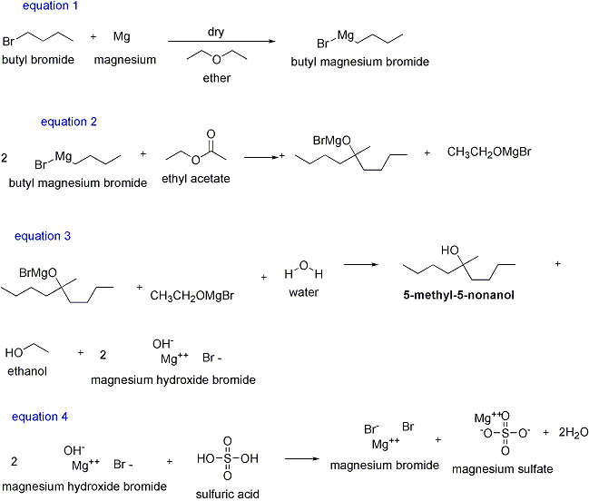
Some of the side products arise from reaction of the Grignard reagent with water, oxygen, carbon dioxide; others are products of the Wurtz reaction of n-butyl bromide with magnesium, and the dehydration of the final product.

REAGENTS:

Reactants: 1. Magnesium, 1-bromobutane, ethyl acetate
2. Conc. H2SO4

Solvents: 1. ether (3 additions)
2. water

Calculate and use the amount of these reactants required to produce 14 g of 5-methyl-5-nonanol assuming an 80% yield.

When calculating amounts of reactants, round mole values to 2 decimal places, final masses to 1 decimal place and volumes to whole numbers.

PHYSICAL CONSTANTS:

5-Methyl-5-Nonanol Boiling point - 195 oC at 760 Torrs

nD20 - 1.4346

Solubilities:

H2O - insoluble
ether - soluble

5-Methyl-4-nonene Approximate Boiling point -
160 oC at 760 Torrs

APPARATUS:

A 500 ml 3-necked round-bottom flask is equipped with a stirrer with a rubber seal, a reflux condenser with a drying tube, and a 125 ml dropping funnel. All glassware must be clean and acetone dried. This must be assembled and checked out the period before running the Grignard reaction.

DIRECTIONS:

1. In the hood the magnesium is placed in the flask and the flask gently heated with a soft flame (a flame that shows no inner cone, yet is not smoky). This will evaporate absorbed moisture from the surface of the magnesium and the glass. When the flask has cooled, 85 ml of anhydrous ether is added to the magnesium through the dropping funnel. The n-butyl bromide is dissolved in 40 ml of anhydrous ether and put into the dropping funnel. About 5 ml of the halide solution is allowed to flow into the flask from the funnel, and a starter solution added. The reaction generally begins within a few minutes as evidenced by a cloudy appearance, and the start of gentle refluxing. Once the reaction begins the stirrer is started and the remainder of the halide solution is added at such a rate that gentle refluxing takes place. A pan of ice may be necessary to moderate the reaction.

After the n-butyl bromide solution has been added (it should take 30 - 40 minutes) the cooling bath is removed and stirring is continued 15 minutes longer, after which only a small residue of magnesium remains. The acetate ester dissolved in 20 ml of anhydrous ether is added through the dropping funnel at such a rate that the ether refluxes gently. Once refluxing begins, this may or may not require cooling in ice. The addition of the ester/ether solution should take 30 minutes. The cooling bath is removed and stirring continued for 10 minutes.

2. The flask is then cooled in a ice bath and, with rapid stirring, 17 ml of H2O is added through the dropping funnel at such a rate that rapid refluxing occurs. Following this, 7 ml of concentrated sulfuric acid in 67 ml of water is added. After the acid is added the two layers become practically clear. The liquid layers are transferred to a separatory funnel and the layers separated. The ether layer is washed once with a 10% sodium hydroxide solution, once with water, and once with a saturated sodium chloride solution. The ether is then dried over anhydrous magnesium sulfate, filtered through fluted filter paper and the ether removed by vacuum evaporation. The residue is transferred to a distilling apparatus with a distilling cow and vacuum distilled. The product should be turned in, the physical constants reported and an IR spectrum and NMR spectrum of the product run.

TPS
Revised 08/15

