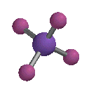 | CHEMISTRY 241  Organic Chemistry 1 Laboratory

Table of Contents

Syllabus/Notebook Writing/Web Resources…………………………………………………………..2

Experiment 1: Distillation………..……………………………………………………………………….8

Experiment 2: Recrystallization………..………………………………………………………………..16

Experiment 3: Preparation of Cyclohexanol………..………………………………………………….24

Experiment 5: Forensic Investigation………..………………………………….………………………35
Experiment 7: Nucleophilic Substitution Reactions………..……………….…………………………36

Chemistry 240 is a pre-requisite/co-requisite for Chemistry 241.
Please arrive on time. You will perform the current experiment after your instructor discusses various aspects of the work and any changes in procedure. During this time, listen carefully to what your instructor is discussing; do not perform any lab related activity during this time.

Safety goggles/glasses must be worn at all times.
Materials required (for first meeting):

- A ¾ length long sleeve lab coat
- Bound laboratory notebooks (3)
- Calculator
- Safety goggles/glasses

Course Objectives

The Course content and learning outcomes are found on this link:
http://rcbc.edu/files/PDFFiles/publications/Catalog/RCBC1819Catalog_082818.pdf

Grades

- Pre-lab write up and quizzes (done prior to lab, included in experiment grade)
- Laboratory notebook – 20% for each experiment

Safety and Dress Code

Anyone present in the laboratory must be properly dressed at all times. This means proper eye protection, no open-toed shoes, no bare midriffs, no shorts or short skirts, tops must cover the entire shoulder (better still, the entire arm). Anyone not complying with these rules will be asked to leave the lab. This will not count as an excused absence. If you must leave the lab for some reason before you are finished, bring your goggles with you. As long as you are in the lab, you must wear goggles, even if you are no longer working with chemicals.

No food or drink may be brought into or consumed in the lab. For the purpose of this course, chewing gum is considered a food. Any container of food or drink brought into the lab may be considered contaminated and disposed of by laboratory personnel. This is especially true of unsealed containers of water or other drinks. Once the safety seal is broken, any fumes in the lab can penetrate the container and contaminate its contents.
Academic Honesty

You are being graded on the work you perform. Use of lab reports from other students (past or present) or other improper resources is expressly forbidden. Both the lender and the borrower are subject to severe penalties, the least of which is failing the assignment. Some discussion about the labs is acceptable at the discretion of the instructor, but you must perform all the work (including the data analysis and answering of questions) yourself. The instructor is free to ask you at any point to explain what you are doing. If you are confused, ask for help. Don’t just copy an answer.

Absences

The lab instructor must be notified about a student’s absence prior to the next lab class by email. Failure to notify the lab instructor may result in a grade of zero on the report for the missed experiment. You must provide suitable documentation of all absences in a timely fashion. If you miss a lab and cannot make it up, it will be considered either excused or unexcused. An unexcused absence will result in a zero grade for the missed experiment. For excused absences, the opportunity to complete missed work may be provided. You must attend the lab section for which you are registered unless prior arrangements have been made. Arrangements must be made in advance.
If you are sick or are injured, follow your doctor’s orders and notify the instructor by email. We will never punish a student for being ill. While it is in your best interest to perform each experiment, this should not be done at the expense of your health. It is important that you provide documentation of physician visits for illness. While the note does not need to include the nature of the illness or any unnecessary private details, we do require at least the ability to verify your physician saw you around the date of your illness. If you become ill during the lab, let the instructor know immediately! We will excuse your absence if you become ill during the experiment and will attempt to provide any assistance that we can.

Preparation
It is critically important that you come prepared for every experiment and have your time planned out. This includes completion of data sheets for each lab and instructor approval being granted to begin the experiment. If your notebook is incomplete in preparation or you arrive late, there may be a grade penalty and possibly forfeiture of the laboratory period.

Schedule

See your instructor for detailed schedule.
You must complete the pre-lab write-up/quiz and submit prior to starting new experiments!

Late Policy
Late work is not accepted under any circumstances. If you need to make arrangements to turn your assignment in prior to the due date, you should make prior arrangements by email.

Plagiarism

Plagiarism cannot be tolerated in an academic environment. Plagiarism is the appropriation or imitation of the language, ideas, or thoughts of another author, and representation of them as original work. You should not paraphrase what others have written unless it is clear where the original ideas can be found. Similarly, when using reaction mechanisms, figures, or tables from another work, the origin should be reported. There will be zero tolerance for plagiarism. The first offense will result in a verbal and written warning, the second offense will result in an F on the experiment in question and will be considered a violation of the College’s Academic Integrity policy.

Notebook writing (by T. Sherlock) – please write (or print) neatly. Key elements to consider:

- ABSTRACT:
- Does it have the proper scope and depth for an abstract?
- Would someone reading this abstract know what was done and why it was done?
- In other words, does the abstract include the objective of the research, results, and a concluding statement? What is the conclusion?
- Does it include data and facts and avoid subjective terms and pronouns?

- ANALYSIS:
- It is comprehensive? Does it propose reasonable explanations for yield and purity results in synthesis experiments?
- When applicable, does it address the mechanism of the reaction?
- When applicable, does it address side products?
- Purification techniques?

- EXPERIMENTAL PROCEDURE:
- Does it include enough detail for someone to reproduce the work and obtain the same results?
- Does it contain key observations, dates, and conditions?
- Does it contain any modifications to, or elements not explicit in the general procedure?

- SPECTRA/CHROMATOGRAMS/SUPPORTING INFORMATION:
- Are all required spectra/chromatograms present?
- Are they clearly labeled?
- Do they contain required sample preparation and instrument data?
- Are key elements identified and compared to standards?

- DATA TABLES:
- Are they comprehensive and neat?
- Do they contain the proper units when required?
- Does the data table serve to help the reader understand the results and conclusions?

- FLOW SHEETS:
- Does it accurately diagram what was done in the experimental procedure?
- Are all reagents, side products, and final products accounted for?

- CALCUALTIONS:
- Are all required calculations present? There should be one example of each unique calculation.
- Are they accurate, clearly labeled, and include the proper units?

- TECHNIQUE:
- Does the student work safely, wear personal protective equipment, keep the lab clean, and dispose of waste properly?
- Does the student effectively use instrumentation and lab equipment?
- Is the report neat?
- Does it follow the protocol for keeping research quality notebooks?
Laboratory reports may be typed, however the notebook must accompany the report and be readable, legible, and of scientific quality. Appropriate dating and signing of laboratory notebook pages is expected and required. Low-quality notebooks will affect report grades.
The Laboratory Notebook (adapted from R. Fleming)

The laboratory notebook is the primary form of documentation in the research laboratory. A laboratory notebook is a legal document. If something was not written it was not done. It can be used to establish a patent claim, to assign credit for a discovery, to document data for publication, and document historical data. It is critical that the notebook be used properly and consistently. Since the laboratory notebook has legal significance (in your case grading significance), the following formatting rules, guidelines, and specifications apply:

- Enter your name, class, and book number on the outside cover for identification.
- Number every page of the book, right side only.
- Label the top of the first page of the book as “Table of Contents”
- All entries are in chronological order by date.
- All entries are in black pen.
- All entries are made directly to the notebook (no scrap paper or other notebooks).
- Entries are made on right-sided pages only; left-sided pages are for class notes, calculations, or instructions.
- State sources for all literature values or outside sources of information.
- Every right page is dated when an entry is made.
- Every right page has the experiment number, experiment name, and the date as a header.
- Every right page is initialed when completed.
- The Table of Contents shall reflect all entry pages by experiment number and a name with page numbers and dates of the work.
- Never rip out any pages.
- Cross out with a single line and initial the cross out for mistakes. Do not erase or white out mistakes.
- Do not leave blank pages or blank areas on a page. Draw a diagonal line through the unused portion or pages.
- Tables may be drawn in or taped in from a lab manual or spreadsheet.

Sections in the notebook shall be organized as such:

- Purpose
- General procedure
- Reaction equations
- Preliminary calculations
- Physical constants table
- Diagrams or charts
- Data table
- Experimental calculations
- Experimental procedures
- Supporting information: IR spectra, GC chromatograms
- Analysis
- Abstract

Items 1-7 should be completed (item 7 partially completed) prior to beginning work on an experiment.
Sample Analysis:

Experiment 1

Example:

Part 1: By a comparison of the experimental boiling point range of the fractions collected and the literature boiling point of the two pure liquids, determine whether any separation was achieved; from the percent recovery of fractions A and B, comment on the efficiency of the distillation.

One fraction was collected from 78 ºC to 81 ºC. Since this range encompasses the literature boiling points of ethanol (78 ºC) and of 2-propanol (82 ºC), no separation of the two pure liquids was achieved. The percent recovery of fractions A and B is zero and the efficiency of the distillation is zero.

Sample Table of Physical Constants

Name,  Structure  and Formula | MW/FW  (g/mol) | CAS # | State | BP (l)  MP (s)  (Flash point?) | Liquid density (g/mL) at 25 ºC | CHP  (H / F / R) | Solubility in water and ether | Refractive index  (n_{D}^{T})
Ethanol  C₂H₆O | 46 | 64-17-5 | Liquid | 78 ºC  (9 ºC) | 0.789 | 0 / 3 / 0 | Water: miscible  Ether:  miscible | 1.361

All reagents used in the main reaction, all products from the main reaction, all side products from any side reactions, and all compounds used in purification and characterization should be present. If a compound is used in purification as an aqueous solution it should be so designated.

CHP: The CHP numbers correspond to health, flammability, and reactivity

MP/BP: Should be included for all reagents used in the main reaction. Should be given for the main product. They should be given for side products and secondary products if their solubilities are similar to the solubilities of the main product. Should be given for purification solvents in which the main product is soluble. Not necessarily needed for any purification compound used as a water solution or any drying agent.

Density: The density of the liquid given is temperature-specific. The density of most liquids is often found in handbooks as d₄, or the density at a given temperature relative to the density of water at 4 ºC. Since this is usually about room temperature, this density may be used.

For saturated solutions, the Merck Index, Miscellaneous Tables section has a table of saturated solution which gives the concentrations in g / 100 mL water (% w/w). For a less than saturated solution, density may be approximated using the above table. For example, for a 10% w/w of sodium hydroxide, the density of a saturated solution (50.8% w/w) solution is 1.51 g/mL. The difference between this density and the density of water is 0.51 g/mL and is due to the approximately 1/5 the concentration in the saturated solution, so an increase in density for a 10% solution would be approximately 1/5 times 0.51 which is 0.1. Therefore, the density of a 10% solution is approximately 1.1 g/mL.

Solubility in water (polar) and ether (non-polar) solvents is needed for all compounds in the experiment. Sometimes the solubility of another solvent is needed i.e. ethanol if a solid product is to be recrystallized from ethanol.

Definition of solubility: The limit of solubility will be taken as 3 g / 100 mL of solvent; a substance is soluble in a solvent if 3 g or more dissolves in 100 mL of the solvent. However, few references give the solubility as g / 100 mL solvent so the following guidelines are helpful and to be used:

The Handbook of Chemistry and Physics uses a solubility classification which may be used:
i – insoluble
s – soluble
vs – very soluble
ss – slightly soluble (less than 3 g / 100 mL but not insoluble)
m – miscible
If no temperature is given, it is assumed to be room temperature.

The Merck Index requires conversion to g / 100 mL. For example, if 10 g / 160 mL H₂O were given, this is equal to 6.25 g / 100 mL ( 10 g / 160 mL x 100 mL = 6.25 g / 100 mL ).

Soluble in x parts – this means that 1 part solute is soluble in x parts solvent, both solute and solvent being in either grams or mL. This is usually used when a solvent is very soluble in the solvent; soluble parts in 5 parts water: 1/5  20/100.

x % (in solvent):

- w / w – x grams are soluble in 100 g of solution for the solvent cited
- w / v – x gams are soluble in 100 mL of solution for the solvent cited
- v / v – x mL are soluble in 100 mL of solution for the solvent cited

If no solubility data is given, the solute is assumed to be insoluble in that solvent. Especially true for inorganic, ionic compounds in non-polar solvents (they are insoluble).

Refractive index, n_{D}:

For liquids, the refractive index is entered for the main product and any reagents/products/side products with solubilities and boiling points in the main product.

Submitted products should be labeled with:
- Experiment number
- Chemical compound name
- CAS number
- Student name
- Gram yield
- MP range (if applicable)
- BP range (if applicable)
- Uncorrected refractive index.

Sigma-Aldrich:
http://www.sigmaaldrich.com/Brands/Aldrich.html

Spectral Database for Organic Compounds:
http://sdbs.db.aist.go.jp/sdbs/cgi-bin/cre_index.cgi

NIST Chemistry Workbook:
http://webbook.nist.gov/chemistry/

ChemSketch Freeware:
http://www.acdlabs.com/resources/freeware/chemsketch/

Merck index:
http://www.rsc.org/merck-index/

Prof. Sherlock’s website:
http://www.chemistry-solutions.com/
http://www.chemistry-solutions.com/800x600/che-241.htm

Wikipedia (http://www.wikipedia.org) is a useful resource but should not be used first-line for information; it is recommended that you verify information obtained from Wikipedia with another source.

Google (http://www.google.com) is also a good starting point for quick reference.

Physical Constants, Hazards and Precautions, and Safety Information
http://www.inchem.org
http://www.chemfinder.com
http://www.avantormaterials.com/
http://www.msds.com
http://physchem.ox.ac.uk/msds/
http://www.skylighter.com
http://www.cdc.gov
http://www.state.nj.us/health/eoh
Useful websites will end in with .gov, .edu, .us, or occasionally .org; avoid .net or .com websites as their information is usually from someone trying to sell a product and may not necessarily be accurate.

Experiment 1 – Distillation

Objectives:

1. Set up a distillation apparatus
2. Separate a two-component mixture by simple distillation
3. Determine whether separation of the two liquids occurs
4. Determine percent recovery of the two liquids
5. Determine efficiency of the separation

Introduction:

Distillation is an excellent method for purifying a liquid. A liquid contains closely packed but mobile atoms or molecules of varying energy. When a molecule of the liquid approaches the vapor-liquid phase boundary, it may, if it possesses sufficient energy, pass from the liquid phase into the gas phase. Only molecules energetic enough to overcome the forces that hold them in the liquid phase can escape into the vapor phase. Some of the molecules present in the vapor phase above the liquid may, as they approach the surface of the liquid, enter the liquid phase and thus become part of the condensed phase. In so doing, the molecules relinquish some of their kinetic energy (i.e. their motion is slowed). Heating the liquid causes more molecules to enter the vapor phase; cooling the vapor reverses this process. When the system is in equilibrium, as many molecules are escaping into the vapor from the liquid phase as are returning from the vapor to the liquid. The extent of this equilibrium is measured as the vapor pressure. If the system maintains equilibrium even when the energy is increased, more molecules in the liquid phase have energy sufficient to escape into the vapor phase. Although more molecules are also returning from the vapor phase, the number of molecules in the vapor phase increases and so does the vapor pressure. The exact number of molecules in the vapor phase depends mainly on the temperature, the pressure, and the strength of the intermolecular forces exerted in the liquid phase and the volume of the system. If two different components (designated A and B) are present in the liquid phase, the vapor above the liquid will contain some molecules of each component. The number of A molecules in the vapor phase will be determined by the vapor pressure of A and by the mole fraction of A in the mixture. In other words, the relative amounts of the components A and B in the vapor phase will be related to the vapor pressure of each pure liquid. This relationship is expressed mathematically by both Dalton’s law (of partial pressures) and Raoult’s law (for solutions):
P_{total} = P_{A} + P_{B} where P_{A} = P°_{A}N_{A} and P_{B} = P°_{B}N_{B}
P_{A} = partial pressure of A, P_{B} = partial pressure of B
P°_{A} = vapor pressure of pure A, P°_{B} = vapor pressure of pure B
N_{A} = mole fraction of A, N_{B} = mole fraction of B (in the liquid)
The total vapor pressure above the liquid mixture is the sum of the two partial pressures of components A and B. As the temperature is raised, the vapor pressure of each component increases, thereby proportionately increasing the total vapor pressure above the liquid. At some temperature the sum of the partial pressures equals 760 torr (1 atm) and the solution begins to boil. More generally, the boiling point is defined as that temperature where the sum of partial pressures above the liquid equals the externally applied pressure on the system. Lowering the external pressure causes the solution to boil at a lower temperature - raising the external pressure causes the solution to boil at a higher temperature. Raoult’s law also provides information as to the composition of the vapor above a liquid:

X_{A} = mole fraction of A in the vapor = P_{A}/P_{total}
X_{B} = mole fraction of B in the vapor = P_{B}/P_{total}
Boiling Point: The boiling point of a liquid is the temperature at which its vapor pressure becomes equal to the ambient (i.e. surrounding) pressure, usually atmospheric pressure. The boiling point is an intrinsic property of a liquid and is important in the identification of a substance; it is easily determined. In actual practice the boiling point (more properly, the range) is obtained during the distillation of the substance, distillation being the last in separation and purification.

Distillation: Distillation consists of the conversion of a liquid to the gas phase, then condensation of the gas phase back to liquid with the collection of this liquid in a separate container. By placing a thermometer in the vapor, the boiling point being collected is determined. Note that this temperature is the boiling point of the condensate, not of the boiling liquid in the "pot".
Distillation of a pure liquid: If a pure liquid is being distilled, there will be no change in composition during distillation and the boiling point will be constant. In actual practice, some difference is almost always found between the initial and final temperature; boiling "points", like melting "points", should be recorded as a temperature range. Since the boiling point depends on the pressure, the pressure at which the distillation is made must also be recorded; if no pressure is specified, it is presumed to be 760 mm Hg (1 atm).

Simple Distillation of a Solution of Two Volatile Substances: The phase diagram of boiling point vs. liquid and vapor composition describes the behavior of a solution of two mutually soluble, volatile substances on distillation. For a typical solution the vapor is always richer in the more volatile substance than is the liquid from which it is distilled. Thus distillation may be used for at least partial separation of two liquids of different boiling points, i.e. of different volatilities. The degree of separation obtained depends on the difference in boiling points of the two liquids: if the two are nearly the same little if any separation is obtained. When the difference is less than 100 ºC, the process is not very effective and repeated distillations are necessary. When the difference is greater than 100 ºC, good separation is usually achieved. Distillation occurs when a liquid is heated in a vessel and the vapors are passed through a condenser, allowing the vapors to convert back to a liquid (see sample apparatus below) that flow into a different vessel from that used for the heating. A simple distillation is considered to be any distillation which does not involve a fractionating column or one in which an one liquid component is separated either from non-volatile substances or another liquid that differs in boiling point by at least 75º. The condensate will have essentially the same mole ratio of liquids as the vapor boiling from the liquid. Simple distillation is not effective in separating closely boiling components of a mixture.
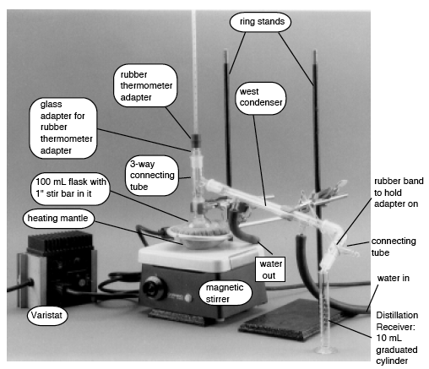

Fractional Distillation of a Solution of Two Volatile Substances: By partially condensing the vapor and returning it to the flask while maintaining good contact between the returning liquid and the upward moving vapor (as in a fractionation column) separation can be improved for liquids with boiling point differences less than 100 ºC. Each time equilibrium is established between two phases is equivalent to a new distillation: the number of times this is accomplished in a column is called its number of theoretical plates. The actual separation achieved for any two liquids depends on the difference in boiling points, the length of the fractionation column and the type of column packing used.

If one plots the course of a simple and a fractional distillation (using corrected thermometer readings), curves approximating those shown in the liquid/vapor distillation temperature-composition curves below will result. These curves provide information as to the efficiency of the separation of components of a mixture. Another advantage of fractional distillation is that the flat portions (plateaus) of the graph of boiling point (y axis) vs distillate volume (x axis) can be more easily distinguished than in a simple distillation. Therefore, the boiling points are more accurate and can be used to help identify the boiling fractions.

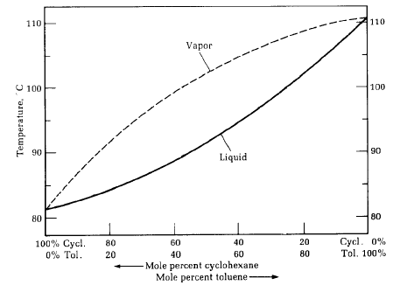

Liquid/Vapor Distillation Temperature-Composition Curves for Cyclohexane:Toluene mixtures
(BP for cyclohexane: 82 ºC, BP for toluene: 111 ºC)

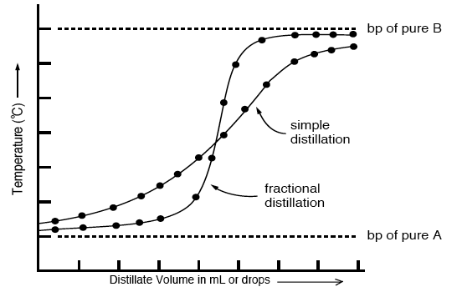
Comparison of efficacy of separation using simple and fractional distillation

Collection of Pure Fractions: As a general rule of thumb, fractions collected between 5 ºC below the literature boiling point of the pure liquid and 5 ºC above are considered to be pure. On the high temperature end of practical bench distillation, about 130 ºC, the low end is extended by five degrees. At the very limit, about 160 ºC, the low end is extended by ten degrees.

Calculations:

Determination of the Percent Recovery: For each fraction collected during the distillation the percent recovery is calculated based on the original volume of liquid mixture that was used:
mL of fraction A
%A = ––––––––––––––––––––––––––––––
mL of original volume used

Determination of the Efficiency of a Distillation: The efficiency of a distillation is based on the amounts of pure liquids obtained from the distillation and is calculated using the following formula:

%A + %B
Efficiency = ––––––––––––––––––––––––––––––
%A + %I + %B

where A is the low boiling point pure liquid, I is the intermediate, and B is the high boiling point pure liquid.

Examples:

- Calculate the mole fraction of each compound in a 95 g ethanol (C₂H₅OH) and 5 g water (H₂O) mixture.

moles of ethanol: 95 g x (mol/46 g) = 2.07 mol
moles of water: 5 g x (mol/18 g) = 0.28 mol
total moles = 2.07 + 0.28 = 2.35
mole fraction of ethanol: 2.07 / 2.35 = 0.88 (88%)
mole fraction of water: 0.28 / 2.35 = 0.12 (12%)

- Given the following mole fraction and vapor pressures for miscible liquids A and B, calculate the composition (in mole percentage) of the vapor from distilling a binary solution at 150 ºC and 760 mm Hg for the solution:

Given: x_{A} = 0.40 Pº_{A} = 1710 mm Hg
x_{B} = 0.60 Pº_{B} = 127 mm Hg

P_{total} = P_{A} + P_{B}
P_{total} = x_{A}Pº_{A} + x_{B}Pº_{B}
P_{total} = (0.4)(1710 mm Hg) + (0.6)(127 mm Hg) = 760 mm Hg

%x = (x_{A})(Pº_{A})/ P_{total}
%A = (0.4)(1710) / 760 = 0.9 (90%)
%B = (0.6)(127) / 760 = 0.1 (10%)
- For a 50:50 mixture of benzene and toluene undergoing simple distillation:

- what temperature would the mixture begin to boil at?
- what would be the composition of the initial distillate?
- what happens to the composition of the undistilled liquid moving along the line labeled A?
- how could we increase the separation of the two components?
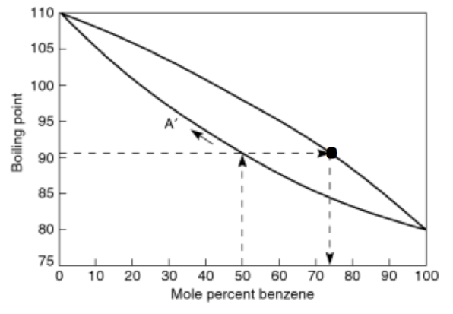

Follow the dashed lines from 50 mole percent benzene up to the liquid line (the lower
line). The mixture begins to boil at about 91 ºC. The composition of the distillate
would be approximately 74 mole percent benzene and about 26 mole percent toluene.
Moving along the line labeled A, the mixture would increase in toluene fraction.
If the initial distillate were to be distilled, from the curve above (identified by the dot), it’s
boiling point would be about 85 ºC, and the composition of its initial distillate would be
approximately 90 mole percent benzene and 10 mole percent toluene. Thus, this
separation would be better suited for fractional distillation since as the number of
theoretical plates increases the better the separation becomes.
Procedure for Distillation:

In this experiment, simple distillations of three liquid mixtures, with three different boiling point separations, will be done. The percent recoveries and the efficiency of each distillation will be determined.

General - all distillations: Before lab, determine the "rule of thumb" fractions that should be collected and record them in the data table. If these overlap, no pure fractions can be collected and the entire volume is collected as Fraction I (intermediate fraction).

The position of the mercury bulb of the thermometer is very important; the entire bulb should be immediately below the side arm so that the vapors must surround the bulb before passing into the condenser. Place one or two boiling chips in the flask (to promote even boiling and avoid bumping). Do not distill until there is no liquid left.

During the distillation, check the distillation rate. If an acceptable distillation rate is not obtained, adjust the varistat until an acceptable rate is obtained. After the last fraction is collected, turn the distillation off and let cool before disassembling. Empty all liquids into the appropriate used mixture container.

For parts 1, 2 and 3, calculate the %A, %I and %B obtained based on the initial 50 mL mixture originally used. Calculate the efficiency of the separation for each distillation.

Part 1: Ethanol and 2-Propanol
ethanol

Use the 100 mL round bottom standard taper flask, matching still head, narrow condenser and adaptor to assemble a distillation apparatus (see sample set-up). Add 50 mL of a 50:50 (by volume) mixture of ethanol and 2-propanol (isopropyl alcohol) and distill. Record the first drop vapor temperature and the high temperature reached during distillation. Measure and record the volume of the fraction collected. Disassemble the distillation apparatus, placing the fraction collected and the liquid remaining the pot into the appropriate waste container.

Part 2: Cyclohexane and Toluene
cyclohexane toluene

Using the same apparatus as Part 1, distill 50 mL of a 50:50 (by volume) mixture of cyclohexane and toluene. Note that the temperature changes throughout the distillation. Collect three fractions according to your calculated temperature ranges and measure the volume of each fraction. The varistat setting may need to be increased to keep the rate constant. Record the first drop vapor temperature and the high temperature reached for each fraction. To separate all of this mixture into even these impure fractions would require repeated distillations of intermediate fractions. Disassemble the distillation apparatus, placing all the fractions collected and the liquid remaining in the pot in the appropriate waste container.

Part 3: Acetone and Cyclohexanone
acetone cyclohexanone

Using the same apparatus as Part 1, distill 50 mL of a 50:50 (by volume) mixture of acetone and cyclohexanone. Note that the temperature remains constant while acetone is distilling, then drops. When the temperature drops 5º below your experimental high temperature for Fraction A, change receivers and increase the varistat setting by 20º. Continue increasing the varistat setting by 5º increments every 5 minutes until Fraction B starts to distill. Collect three fractions according to your calculated temperature ranges (A, I, and B) and measure the volume of each fraction. Disassemble the distillation apparatus, placing all the fractions collected and the liquid remaining in the pot in the appropriate waste container.

Pre-lab writeup:

Physical constants sheet for the six chemicals used. You should design you own data table, however data to be included are rule of thumb temperature ranges, actual experimental BP ranges, identities, and volumes of fractions, barometric pressure and distillation rate in drops per minute, and calculated efficiency

Analysis/Results:

Part 1: Compare the experimental boiling point ranges of the fractions collected and the literature boiling points of the two pure liquids, determine whether any separation was achieved. From the percent recovery of fractions A and B, comment on the efficiency of the distillation.

Parts 2 and 3: Compare the experimental boiling point ranges of the three fractions collected and the literature boiling points of the two pure liquid. Include the volumes collected for the three fractions and determine whether any separation of pure liquids was achieved. From the percent recovery of fractions A and B, comment on the efficiency of this distillation.

In general, comment on the relative efficiency of separation by simple distillation as a function of the difference of the boiling points of the two liquids being distilled. Be sure to include the barometric pressure.

Notes:

1. If a reflux ring is observed in the distillation head, the thermometer should be placed with the top of the bulb just below the reflux ring, instead of just below the side arm.

2. NEVER HEAT A SYSTEM WITH NO REMAINING LIQUID. It is not safe to heat a distillation flask when there is no liquid left. Remove the heat just before the flask goes completely dry, usually when the boiling chips become visible through the foam.

3. A reasonable rate of distillation is important - some 25 to 45 drops of condensate per minute is about right. Too great a heat will cause flooding of the still head or additional heating of the vapors: the latter prevents liquid-vapor equilibrium so that the temperature reading is not the boiling point. Too small a heat results in intermittent distillation, with fluctuating and meaningless temperature readings. However, even in the acceptable range speed of distillation is usually traded for lost efficiency. If you have difficulty controlling your varistat, ask for help.

4. Be gentle in assembling apparatus with ground glass joints. There is no flexibility. Tighten clamps and holders gently. Before putting ground glass joints together, grease inner member with a light film of "Lubriseal". Use just enough so that the ground glass loses its frosted appearance: too thick a film will dissolve out and cause leaks.

5. It is safer to attach the rubber tubing to the condenser and to insert the thermometer in the thermometer adapter before assembling the apparatus. The cooling water should flow in the lower end, out the upper end (“in the bottom and out the top”), of the condenser jacket; use a gentle flow of water. Before distilling check to see that all the joints in your apparatus are tight: leaking vapors cause fires and loss of substance being distilled. Use clips if joints are not tight.
References:
Organic Laboratory Techniques 2nd Ed., Fessenden and Fessenden

Simple Distillation: Technique 5, 5.1 & 5.2 pp.94-108
Fractional Distillation: Technique 6,6.1 & 6.2, pp.109-113
Heating Mantles: p. 31

Introduction to Organic Laboratory Techniques, 3rd Ed., Pavia, Lampman and Kriz

Boiling Points, Simple Distillation: Technique 6, 6.1, 6.3, 6.4: pp. 551-558
Fractional Distillation: Technique 7, 7.1, 7.4 - 7.6: pp. 565-575
Heating Mantles, 1.5: pp. 508-509
Boiling Stones, 1.6: pp. 511-512
"Lab Guide for Chemistry 35 & Chemistry 36: Introductory Organic Laboratory"
Minard, Masters, Halmi & Williamson, 2002-2003 Edition published by Hayden McNeil, pp. 61-72.

Experiment 2 – Recrystallization and Melting Point Determination

Objectives:

1. Recrystallize a solid from a single solvent.
2. Recrystallize a solid by decolorization and a single solvent.
3. Recrystallize a solid from a mixed solvent.
4. Determine the melting point range of a pure substance.
5. Determine the melting point range of an impure substance.

Introduction

The final purification of most compounds which are solids at room temperature is best done by recrystallization: dissolving in a limited quantity of hot solvent, then slowly cooling to induce the substance to crystallize out of the solution. This process presupposes that a proper solvent has been found.

Solvent Selection: Recall, “like dissolves like”: the observation that only molecules of similar structure will be soluble in each other (polar molecules in polar solvents and non-polar molecules in non-polar solvents). The initial consideration in recrystallization is selection of a solvent. For a single solvent to be used the compound must be highly soluble in the hot solvent, but only slightly soluble at room temperature or below. This large temperature difference in solubility is required for good recovery of the compound. The solvent should be volatile so that the recrystallized material can be dried easily.
The solubility for the impurities will differ from one solvent to another; sometimes the use of different solvents in successive recrystallizations is necessary to get high purity. In any case, recrystallization may be repeated until the melting point of the product indicates that the desired degree of purity has been reached.

Sometimes no single solvent suitable for recrystallization can be found; in such cases a mixed solvent method is used. Two solvents are used, one in which the compound is highly soluble, the second in which the compound is only slightly soluble. The two solvents must be mutually miscible. Some common solvents arranged by decreasing polarity:

 | 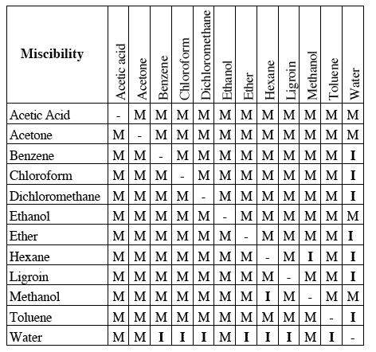  ( M = miscible, I = immiscible )
  MOST POLAR
  Water (H₂O)
  Acetic acid (CH₃COOH)
  Methanol (CH₃OH)
  Ethanol (CH₃CH₂OH)
  Acetone (CH₃COCH₃)
  Dichloromethane (CH₂Cl₂)
  Chloroform (CH₃Cl)
  Ether (CH₃CH₂OCH₂CH₃)
  Benzene (C₆H₆)
  Toluene (C₆H₅CH₃)
  Hexane (CH₃(CH₂)₄CH₃)
  Ligroin (mix of hydrocarbons)
  LEAST POLAR

Removal of Impurities: In an ideal system, the compound should be completely soluble in the hot solvent and quite insoluble in the cold solvent and the impurities should be soluble at all temperatures. This ideal situation is never obtainable. For obvious reasons, the solvent should not react with the solute. The solvent must have a boiling point lower than the melting point of the compound. In recrystallization, most impurities are removed because the solution, even after cooling, is less than saturated with respect to the impurity; it is left behind, dissolved in the solvent. Some impurities are insoluble in the hot solvent and are removed by hot gravity filtration of the solution. High molecular weight, polymeric material - often colored - can usually be removed by adsorption on charcoal. If an impurity is to be left dissolved in the solvent after the compound has crystallized out, that impurity must not be present in large quantity. Furthermore, many substances cannot be induced to crystallize at all from solutions that contain considerable amounts of impurities. For these reasons all possible means of chemical separation should be used before recrystallization is attempted. In any case, slow cooling gives the best opportunity for the growth of well-formed crystals free from occluded impurities or solvent.

General Technique: The technique of recrystallization is highly variable in the details. However, the overall process usually follows a few general directions.

- The compound is dissolved in the minimum volume of solvent, determined at or near the boiling point of the solvent. This is accomplished by heating the solvent to boiling, adding a limited quantity of hot solvent to the solid, heating the mixture to boiling and adding portions of hot solvent with mixing until the solid just dissolves. Dissolution of a solid does not occur immediately; do not add too much solvent too quickly. Care must be taken to not add a large excess of solvent in trying to dissolve impurities. When the substance to be recrystallized is dissolved in the hot solution, add a slight excess of solvent to prevent premature crystallization.

- The next step depends upon the situation encountered at this point.

(a) If the solution is free of undissolved impurity, leave it to cool slowly.

(b) If there is undissolved impurity, the hot solution must be filtered rapidly without undue
evaporation on cooling. Additional excess solvent should be added. A fluted filter
paper serves best with a heated stemless funnel and the entire set-up is kept hot
during the filtration.

(c) If the solution is colored due to impurities, treatment with charcoal is effective in
removing these impurities before crystallization begins. Additional excess solvent
should be added. Charcoal is added directly to the slightly cooled solution, and the
solution heated for a short time. It is filtered, hot as above, through two fluted filter
papers.

- If hot gravity filtration was used the solution should be checked for excess solvent, and if necessary the excess solvent evaporated. The solution is then left to cool slowly.

- The final cold solution should be chilled with ice to reduce solubility still more before the crystals are separated from the solvent.

- Crystals are separated from the solvent most efficiently by vacuum filtration. Vacuum filtration should leave the crystals nearly dry, unless the solvent has been water, which evaporates more slowly than most.

- Spread the crystals to dry for at least two days in an opened wide mouth jar, before determining the weight and melting point.

The filtrate from the last separation of crystals may often be concentrated to obtain a second crop of crystals. This second crop is often less pure: if too impure, it may itself be recrystallized by the same procedure. If a second crop of crystals is obtained, they must be kept separate from the first crop of crystals.

Sometimes it is difficult to obtain crystals even after the solution is cooled in an ice bath. In this situation crystallization can be induced by scratching the inside of the beaker or flask with a glass stirring rod. This will produce microscopic fragments of glass that may act as surfaces on which crystal growth can begin. If slow cooling and scratching does not produce crystals, crystallization may be induced by seeding: taking a small crystal from the original solid and dropping it into the solution. This will provide a nucleation site for similar crystals to grow.

Melting point determination: Once you have purified the solid by recrystallization, its purity can be verified by determining its melting temperature (commonly called a melting point, but is really a melting range). To better understand this behavior, the theory of melting point determination must be examined. Even small amounts of impurities, ~1%, will lower and broaden the melting temperature range (melting point depression – one of the four colligative properties you once learned about applied to solutions also is applicable here). This behavior of solids is consistent and can therefore be used as a test of whether we have a pure compound or one mixed with some impurities. Thus, a melting point (really melting range) determination is a quick and simple test of a compound’s purity and drug companies will use this and other analyses to assure the purity of any drug compounds they produce. For example, the true melting point range for caffeine is 234 - 237 ° C. If the caffeine is obtained directly from tea and is not purified, the observed melting point is much lower. In fact, crude caffeine extracted from tea bags melts as low 180 - 220 ° C. This melting range is significantly different from the true melting point and can be used to determine that it is impure. Purity can be determined by evaluating the melting point range. When an impurity is soluble in the compound, the melting point will be depressed. The figure below is a melting point composition diagram that shows how the melting temperatures are affected in a two-component mixture. Either component may be regarded as an impurity in the other component.
(Note: Ep = eutectic point, the mole percentage where both compounds are equally dissolved in each other; Et = eutectic temperature, lowest temperature at which the mixture begins to melt.)

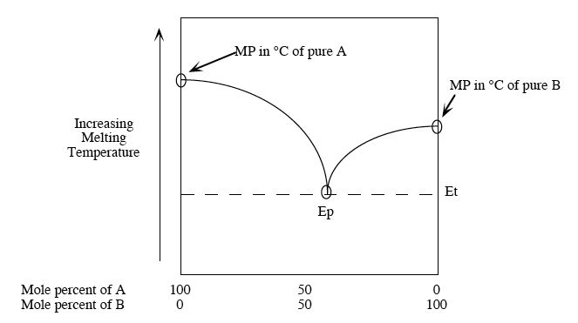

Procedure for Distillation:

This experiment will involve recrystallization of three substances:

Structure:
Substance: | benzil | acetanilide | 2-naphthol
Recrystallized from: | ethanol | water | mixed solvent
Solubility data: | Water: insoluble  Ethanol: soluble  Ether: soluble | Water: 1 g/185 mL (cold),  5 g/100 mL (boiling)  Ethanol: 1 g/3.4 mL (cold),  29 g/100 mL (boiling)  Ether: 1 g/18 mL (cold),  5.6 g/100 mL (boiling) | Water: 0.0876 g/100 mL at 29.55 ºC  Ethanol: 55 g/100 mL at 5.5 ºC
Benzil:

Weigh approximately 1 g of benzil (record actual weight in the Data Table) into a 125 mL Erlenmeyer flask, then dissolve in hot ethanol by gradually adding small quantities to the flask containing the benzil. After the initial addition, the flask containing the hot ethanol and benzil should also be kept warm until all the crystals have dissolved. The solution is then allowed to cool to room temperature and then placed in ice. The crystals are filtered by vacuum through a Buchner funnel (see below). The crystals are removed from the funnel, allowed to dry, and saved for melting point determination. The flask can be washed with cool solvent to assist in crystal transfer. The filtrate is placed in the waste ethanol container.

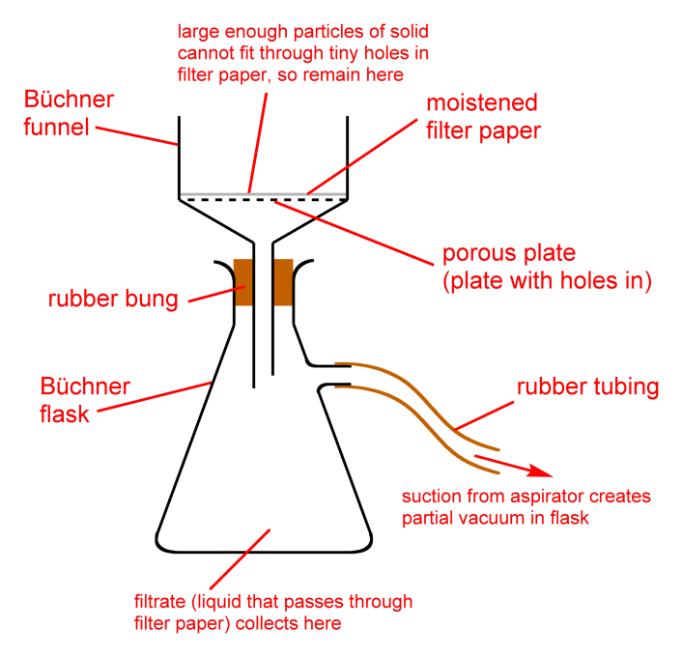
Acetanilide:

The starting material is crude and must be decolored using charcoal. Weigh approximately 1 g of acetanilide into a 150 mL beaker, add an initial 20 mL of hot water then gradually add hot water to the acetanilide, keeping hot until the crystals just dissolve. When the acetanilide is dissolved, add a slight excess of hot solvent to prevent crystallization during decoloring. The solution is then removed from the hot plate, a pinch of charcoal is added to the solution, and the solution returned to the hot plate for 5 minutes. Make sure that an excess of solvent is still present. To remove the charcoal, the solution is filtered through two fluted filter papers in a stemless funnel, which has been preheated, into a small beaker on the hot plate. Excess solvent is evaporated off if necessary. The filtrate is cooled and the crystals are vacuum filtered as before. The crystals are removed from the funnel, allowed to dry and saved for melting point determination. The filtrate may be discarded down the sink drain.

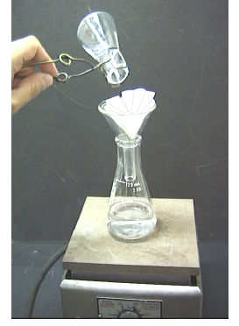
Example of hot filtration set-up.

2-naphthol:

The pure compound is colorless while the technical grade is purple. Recrystallization removes much of this color. Treatment with charcoal would remove even more, but is not required in this experiment. The solubility of this compound in water (0.0876 g/100 mL of solution at 29.55 ºC) is too low to permit recrystallization from a convenient volume; the solubility in ethyl alcohol
(55 g/100 mL at 5.5 ºC) and most other solvents is too high. The best approach is to use a mixture of water and ethyl alcohol.

Weigh approximately 1 g of technical 2-naphthol into a 50 mL beaker and then dissolve in 5 mL of hot ethyl alcohol. Test the suitability of this solvent for recrystallization by cooling the solution. Re-warm the solution to room temperature and slowly add cold water until the solution becomes slightly cloudy and remains cloudy upon swirling. Place the solution back on the steam bath until the cloudiness disappears. Remove the solution from the steam bath and cool immediately in an ice bath. Scratch the sides and bottom of the beaker to promote crystallization. Vacuum filter the crystals as in previous procedures. Leave the 2-naphthol crystals in the Buchner funnel to dry. The filtrate may be discarded down the sink drain. After drying at least three days, remove the crystals from the funnel, and save them for melting point determination.

[End week 1 after completing all recrystallizations. Week 2 will require samples to be dried prior to melting point determination.]
Procedure for Melting Point Determination:

The Mel-Temp apparatus is used to determine the melting point of your solids. A ground sample of your substance is placed in a capillary tube. Push the crystals into a small pile and then push the open end of a melting point capillary tube into the crystals so that some solid is forced into the opening of the tube. The sample is then shaken down into the closed end of the capillary by dropping it down a 2 to 3 foot length of 5-10 mm tube onto a hard surface. If necessary, push more crystals into the open end and pack it down into the closed end so that you have no more than 2-3 mm column of solid at the bottom of the capillary tube. When a melting point apparatus becomes available be sure that it has cooled to below 70 °C prior to using.

The "mixed melting point" is of particular help in the identification of an unknown. When enough information has been gathered to permit an educated guess, a quick test may be made by intimately mixing the unknown with a known sample of the substance. If the two are the same, there will be no change in the melting "point"; if they are different, the mixture will have a lower (and broader) melting range. Refer to the introduction above in terms of phase diagrams and effect of impurities on melting points.

The material tested should be ground so that fine, uniform crystals are used, and the capillary tubes for multiple trials should be packed with equal amounts of material in order to give reproducible results. Care must be taken to use the correct amount of material in the capillary tube; too much material will give an inaccurate, broad, high melting point range; too little will give irreproducible results. Care must also be taken with the rate of heating at the melting point, too fast a rate will again give an inaccurate, broad, high melting point range.

Pre-lab writeup:

Physical constants sheet for the three chemicals used. You should design you own data table, however data to be included are literature melting point ranges, observed melting point ranges, and percent recovery of your recrystallized compounds.

Analysis/Results:

Recrystallization: Comment on the yield recovered from recrystallization.
Melting Point Determination: From a comparison of the melting points of the original and purified materials with the literature melting point, comment on the purity of these materials; from a comparison of the melting points of the original and purified materials to each other comment on the effect of recrystallization.

Notes:

1. All flammable solvents are contained in Erlenmeyer flasks and heated on steam baths.

2. When using a Buchner funnel during vacuum filtration, the filter paper is always wet with cold solvent and suction applied to seal the system before filtration.

3. Solids are placed in wide mouth jars. The jar should be labeled prior to weighing and weighed empty. When the crystals are dry (allow at least two days for drying) reweigh the wide mouth jar with the crystals and determine the mass of the recrystallized product: this is the number of grams of recovered crystals used to determine the percent recovery.

mass of recovered crystals
% recovery = ———————————————— x 100%
mass of crude crystals

4. Water may be heated on a hot plate and worked with in beakers since it is non-flammable.

References:
Organic Laboratory Techniques, 2nd Ed.; Fessenden and Fessenden

Crystallization: Technique 1, 1.1 - 1.3, pp. 38 - 53
Melting Point: Technique 2, 2.1 & 2.3, pp. 55-60 & 63 - 64
Steam Baths: pp. 30-31

Introduction to Organic Laboratory Techniques,3rd Ed; Pavia, Lampman and Kriz

Safety Precautions with Solvents, 1.1; Steam Cones, 1.3: pp. 505-506; Hot Plates, 1.6: p. 509
Filtration: Technique 2, 2.1, 2.3, 2.5, pp. 514-521
Crystallization: Technique 3, 3.1 - 3.7, pp. 522-531
Benzil (recrystallization only): p. 307
Acetanilide (recrystallization only):pp. 41-42
Melting Points: Technique 4, 4.1 - 4.7; pp. 533-539
"Lab Guide for Chemistry 35 & Chemistry 36: Introductory Organic Laboratory"
Minard, Masters, Halmi & Williamson, 2002-2003 Edition published by Hayden McNeil, pp. 39-60.

Experiment 3 – Preparation of Cyclohexanol

Objectives:

- Write a procedure for a preparative organic laboratory experiment.
- Synthesize an alcohol from an alkene.
- Isolate the reaction product by distillation.
- Learn the concept of liquid/liquid extraction and how it applies to acid-base separation. Extract the reaction product from a distillate using ether, sodium chloride and potassium carbonate.
- Handle ether safely in the experiment.
- Determine the purity of the product by the refractive index.
- Run an infrared spectrum of a neat liquid.
- Determine the identity and structure of the product using the infrared spectrum.

Introduction:

When writing organic reactions, reaction details are specified above and/or below the arrow. Reaction schemes do not have to be balanced. For example:

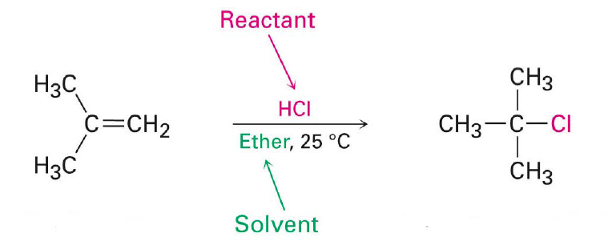

Typically, unless otherwise specified, the ratio of reactant to product is 1:1. In some cases, there may be a specific amount of a second reactant (i.e. nucleophile in a polar reaction) that may have different reaction outcomes depending on the stoichiometric amount used. For our purposes, this ratio will be 1:1. Of note, the amount of a catalyst present does not matter; any amount will be used. Likewise, the solvent amount is typically not a factor because there is so much of it present, even if it a source of the nucleophile used in the reaction. However, there may be cases where the amount of solvent might be limited to prevent unwanted side reactions.

With organic reactions, especially synthetic preparations, it is essential to plan amounts of reagents and to be familiar with physical properties of the reagents being used. A table similar to the data table used for the last two experiments is especially helpful for showing amounts of reagents and predicting theoretical yields.

Liquid-liquid extraction: One important aspect when choosing a solvent system for extraction is to pick two immiscible solvents. Some common liquid/liquid extraction solvent pairs are water-dichloromethane, water-ether, and water-hexane. Notice that each combination includes water. Most extractions involve water because it is highly polar and immiscible with most organic solvents. In addition, the compound you are attempting to extract must be soluble in the organic solvent, but insoluble in the water layer. An organic compound like benzene is simple to extract from water, because its solubility in water is very low. However, solvents like ethanol and methanol will not separate using liquid/liquid extraction techniques, because they are soluble in both organic solvents and water. The volatility of the organic solvent is also important. Solvents with low boiling points like ether are often used to make isolating and drying the isolate material easier. If ether is used (BP = 35 °C) then evaporation to collect the solid is fast.

In order to identify the layers, the densities of common solvents are provided below. The best method to avoid making a mistake is a drop test. Add a few drops of water to the layer in question and watch the drop very carefully. If the layer is water, then the drop will mix with the solution. If the solvent is the mistaken organic layer, then the water drop will create a second layer. In general, this method can help determine the identity of the layer. However, it is still best to keep ALL the layers until the extraction is complete and your product has been isolated.

Solvent | Density (g/mL)
Hexane | 0.695
Ether | 0.708
Toluene | 0.867
Water | 1.000
Dichloromethane | 1.325
Chloroform | 1.492
Once the two layers are mixed, you will need to separate them. You could separate the two layers by pouring off (decanting) the less dense layer into a separate container. You would find that it is difficult to do this cleanly, however. With a water-ether mixture, you would undoubtedly end up with some ether left on top of the water or some water poured off with the top ether layer.

To make the separation of two liquids in liquid/liquid extraction, chemists use a separatory funnel:

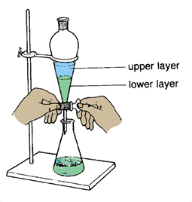

After making sure the stopcock at the bottom is closed (in the horizontal position), the complete reaction mixture including both aqueous and ether layers is poured into the separatory funnel. The lower aqueous layer is drained into a beaker or flask by opening the stopcock. Just as the interface between the two layers enters the stopcock, the stopcock is closed. The ether can then be drained out the bottom or poured out the top into a separate beaker or flask. However, since there are usually droplets of water containing inorganic salts clinging to the walls of the separatory funnel or floating in the ether, chemists often keep or place the organic layer in the separatory funnel and extract it with a volume of pure distilled water. Removing traces of unwanted materials this way is often called washing. Extraction and washing are not very effective unless the two layers are mixed together vigorously to provide maximum surface contact between the two immiscible layers so that substances can be pulled or extracted from one into the other. To do this, the separatory funnel is stoppered. With one hand gripping the top of the funnel so that a finger holds in the stopcock, the separatory funnel is tipped upside down. Gently shake or swirl the funnel to mix the two layers. Open the stopcock with your other hand to relieve pressure that usually builds up from the vapor pressure of ether or another solvent. Vent often and point the funnel away from yourself and classmates while shaking the solution. Since extraction solvents typically have a very high vapor pressure (low boiling point), considerable vapor pressure is created while mixing the two layers.

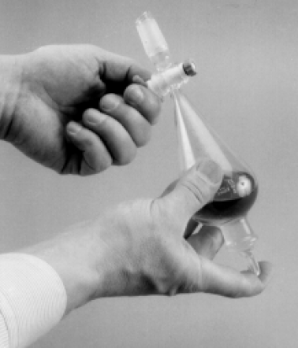

Example:

Benzoic acid is soluble in most organic solvents including dichloromethane and ether. However, this acid can be easily deprotonated with base to give a charged ionic species that is readily soluble in water. By converting benzoic acid to the sodium salt of benzoic acid, the solubility has drastically changed. Now the sodium salt is soluble in the water and will migrate to the water layer. Because the solvents chosen are immiscible in each other, the layers can be easily separated. Although the separation is complete, we no longer have benzoic acid. To obtain the original compound, the salt must be protonated with a strong inorganic acid. Once the benzoic acid is recovered by adding acid, it will precipitate in the water to provide a pure compound. This method works very well with mixtures of strong organic acids, weak organic acids, bases and neutral compounds.

Example: Using a flow chart, show how to separate benzene (PhH), benzoic acid (PhCOOH), phenol (PhOH), and aniline (PhNH₂).

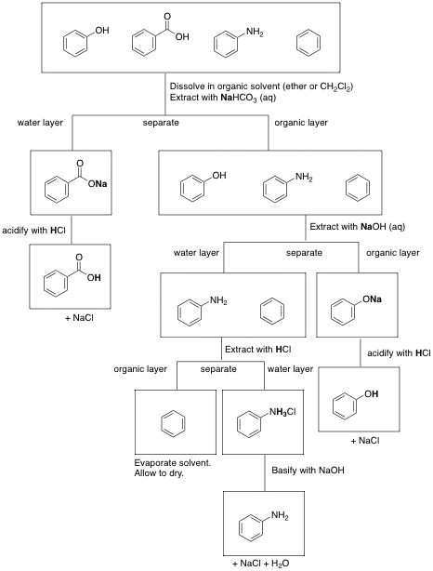

One significant problem with liquid/liquid extraction is that no solvent is completely insoluble in another solvent. In practice, one additional step is usually carried out before evaporating the organic solvent: drying over anhydrous sodium sulfate or other drying agent. Granular anhydrous sodium sulfate is the drying agent most often used although other drying agents are also available. All of the inorganic solids work by reacting with the water to form hydrates, which is their preferred form if water is available. These drying agents do not dissolve in the solvent they are drying. They may change somewhat, for example, sodium sulfate will clump together as it reacts with water, but they will remain solids in normal extraction solvents. This makes them easy to remove by decantation (pouring off) of the liquid or by gravity filtration. Usually the organic solvent will go from cloudy to clear in the process of being “dried”. You should be careful to remove all of these solid drying agents before solvent evaporation or you might think they are your product. When you take a melting point and the product doesn’t melt by 300 °C, you probably have isolated your drying agent. Anhydrous sodium sulfate is a widely used drying agent. Potassium carbonate also works as well, and will serve to neutralize any acid present as it is a basic compound.

Drying a solvent however, is not an exact science. An excess of drying agent should be used to ensure that all the water is removed. If the water remains after the materials are collected, it could interfere with the analysis. Add drying agent until there are no longer clumps of drying agent stuck to the sides or bottom of the flask. The drying agents should be free floating in the beaker, like snow. Do not be afraid to use too much.

Preparation of Cyclohexanol from Cyclohexene

The hydration of cyclohexene to cyclohexanol is an example of electrophilic addition of H—X to π bonds. In this reaction, Markovnikov’s rule applies, carbocations are intermediates, and there is no clear stereochemical preference (achiral reactants/intermediates), and a closer analysis of the equilibrium of the general type of these reactions gives some insight into the setup of the experimental procedure:

∆H_{rxn} = Σ ∆H (bonds broken) – Σ ∆H (bonds formed)

How, then, will we be able to isolate our product from a reaction that favors the reactants? By taking advantage of Le Chateleir’s principle: by removing the product of the reaction from the reaction pot by distillation, the reaction will be driven toward the products.
The mechanism of this reaction is as follows:

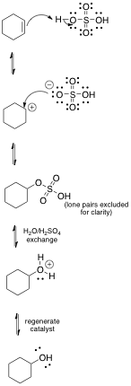 | An acid with a non-nucleophilic anion (such as H₂SO₄, H₃PO₄, and HClO₄) is used as the catalyst; protonation on the less substituted end of the double bond takes place in Markovnikov fashion.  The cyclohexyl hydrogen sulfate intermediate is hydrolyzed to form the oxonium ion. This exists in equilibrium with the previously formed carbocation.  Water (solvent) adds to the intermediate carbocation, giving an oxonium ion (protonated alcohol)  The oxonium ion is deprotonated by water (returning catalytic H⁺)  All steps are reversible; the equilibrium favoring the reactants (alkene and water).

- The carbocation that forms is symmetric, and all carbons are secondary carbons (i.e. equal stability) and the possibility of rearrangements is excluded.
- Since sulfuric acid (a strong acid with a non-nucleophilic anion) is acting as a catalyst, the H⁺ ion used to initiate the reaction must be regenerated and is done so in the last step of the reaction: the protonated alcohol is deprotonated.
- However, the oxonium ion can go in either direction (toward the alcohol or toward dehydration to restore the alkene) – this is termed reversibility and is quite common in many reactions. In order to minimize reversibility, the equilibrium must be driven such that the desired product is formed and formed in sufficient amounts that the reaction is worth doing.

Reaction: As with the example above with the reduction of acetaldehyde, you should make a table in your notebook to keep the amounts organized:

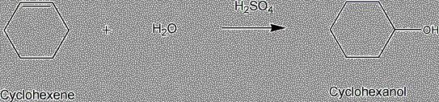
Once verifying your completed your data table with your instructor, begin the experiment. Always add acid to water! In a 500 mL standard taper round bottom flask, add 16 mL of concentrated sulfuric acid and 8 mL of water. Cool the reaction flask in an ice bath until cold to the touch, then add 20 mL of reagent grade cyclohexene. Stopper the flask with a greased ground glass stopper and shake vigorously to mix for at least 15 minutes or until there is one homogeneous layer, holding the stopper in. Let the reaction mixture sit an additional 10 minutes to increase completeness of reaction.

Purification (theory): At the end of the reaction period, the reaction mixture contains protonated cyclohexanol and unreacted starting materials. Cyclohexanol is isolated from the reaction mixture by dilution with water followed by distillation. The distillate contains water and all the compounds in the reaction mixture that are insoluble in water, plus small (trace) amounts of the water soluble compounds as impurities; the remaining liquid in the pot contains water and all the water soluble compounds in the reaction mixture.

Further purification of the distillate can be accomplished based on the solubility of the chemical compounds in water versus ether. Sodium chloride is added to the water to make the water more ionic. This makes the slightly water soluble cyclohexanol less soluble in the water and more soluble in the ether. Ether, being insoluble in water, is used to extract the cyclohexanol from the water solution.

Prior to the final distillation, a drying agent is added to the ether extract of cyclohexanol to remove the traces of water that are left. Potassium carbonate is a good choice of drying agent here for it not only absorbs water, but it also is a base which can neutralize the trace amount of acid left in the ether extract. The ether is removed by vacuum evaporation and the cyclohexanol is distilled for final purification. In the final distillation, if there is still some water present, a cyclohexene-water azeotrope at 71 ºC and cyclohexanol-water azeotrope at 98 ºC will distill off before the pure cyclohexanol distills at 155-162 ºC. (An azeotrope is a mixture of two or more liquids in such a way that its components cannot be altered by simple distillation.)

Purification (procedure): Add 250 mL of water and distill the reaction mixture via a simple distillation using a heating mantle as the heat source and a 250 mL standard taper round bottom flask as a receiver. Distill until the distillate in the condenser is clear, with no oily droplets present, and one phase is left in the pot. Saturate the distillate with 50 grams of sodium chloride and let this mixture stand for 15 minutes. [End week 1 here.]

Transfer the mixture to a 250 mL separatory funnel. Rinse the reaction flask three times with
10 mL of diethyl ether and add all the ether rinsings to the separatory funnel. Extract the reaction mixture with the ether, separate the layers and pour the ether layer into a 125 mL Erlenmeyer flask. Add anhydrous potassium carbonate to the ether layer until free flowing and allow it to stand for at least 10 minutes. Gravity filter this mixture through fluted filter paper into a 250 mL suction filtration flask. Use vacuum evaporation to remove the ether from the mixture using the set-up demonstrated in the laboratory. Transfer the remaining liquid to a 50 mL standard taper round bottom flask. [End week 2 here.]

Distill via a simple distillation using a heating mantle as the heat source. Collect the low boiling fraction in a 100 mL standard taper flask. Change the flask at 120 ºC to a labeled, weighed bottle and collect from 120-162 ºC. Adjust the varistat setting to control frothing. Watch the liquid level in the pot. The distillation should be stopped when the liquid level becomes too low, the temperature drops and/or signs of charring are seen. Weigh the sample and sample bottle to obtain the mass of cyclohexanol produced.

Characterization: Determine the refractive index of the product. Determine the infrared spectrum of the product. The instructor or instructional assistant will demonstrate the operation of the Abbe refractometer and the infrared spectrophotometer.
Pre-lab writeup:

Physical constants sheet for all chemicals used. In addition to the physical constant sheet as described above, you should complete a table like the one described in the procedure:

Name | Formula | Vol. (mL) | MW (g/mol) | BP/MP | Density (g/mL) | mmol | Equivalents
Cyclohexene |  | 20 |  |  |  | 0.20
Water | H₂O | 8 |  |  |  | 0.44
Sulfuric acid | H₂SO₄ | 16 |  | N/A |  | 0.30
Cyclohexanol
Fill in the blanks: You may find useful reference data from the web resources given in syllabus i.e. Sigma-Aldrich, Merck Index, or Handbook of Chemistry and Physics. You should be able to fill all the blanks in without difficulty. (The MP of H₂SO₄ is not necessary/relevant for this experiment.)

Include the mechanism for the reaction being studied. Be sure to include all intermediates and show all steps clearly. (More than one way of describing this reaction may exist. One analogous example is given in the experiment text.)

Analysis/Results:

- Comment on the percent yield of cyclohexanol.

- By comparing experimental and literature boiling points, and the experimental infrared spectrum and the standard infrared spectra, determine the identity of the main product.

- From a comparison of the experimental refractive index and the literature refractive indices determine the purity of the product.

- From the experimental infrared spectrum determine the structure of the product.

- Discuss factors that could cause loss of material and/or impurity of product for procedures discussed above.

Notes:

- Acid is always added to water because concentrated acid reacts rapidly with water generating a large amount of heat. By adding the acid to the water a slower more controlled reaction occurs.

- Reagent grade cyclohexene must be used in the experiment. Impure cyclohexene darkens when shaken with sulfuric acid to the extent that completion of the reaction cannot be detected.

- Instead of shaking the reaction, the mixture may be allowed to stand between the laboratory periods.

- During storage, the stopcock plugs, whether of glass or Teflon, of separatory funnels are left loose. Be sure the plug is in proper operating position and greased if glass, before using your separatory funnel. Ask for assistance if in doubt.

- This is the main product, cyclohexanol, and it should be turned in with your result card. Do not turn in the low boiling fraction.

- The IR spectrum should be run neat on salt plates. Acetone is used in this procedure to clean the salt plates.

References:
Organic Laboratory Techniques, 3rd Ed., Fessenden and Fessenden
Extraction, Technique 3, 3.1-3.5, pp. 68-84
Drying Organic Solutions, Technique 4, 4.1-4.2, pp. 88-90
Refractive Index, Technique 11, 11.1-11.2, pp. 146-150
Typical Reactions, Technique 15, 15.3 pp. 194-195
Infrared Spectroscopy, Technique 16, 16.1A, pp. 201-202

Techniques and Experiments for Organic Chemistry, 4th Ed., Ault, pp. 358-359

Introduction to Organic Laboratory Techniques, 3rd Ed., Pavia, Lampman and Kriz
Extraction and Drying, Technique 5, p. 541-550
Refractometry, Technique 16, p. 654-659
Infrared Spectroscopy, Technique 17, Part A, p. 659-661 and Appendix 3, p. 695-712

"Lab Guide for Chemistry 35 & Chemistry 36: Introductory Organic Laboratory"
Minard, Masters, Halmi & Williamson, 2002-2003 Edition published by Hayden McNeil, pp. 73-92.
Reference spectra from http://sdbs.db.aist.go.jp/sdbs/cgi-bin/cre_index.cgi:

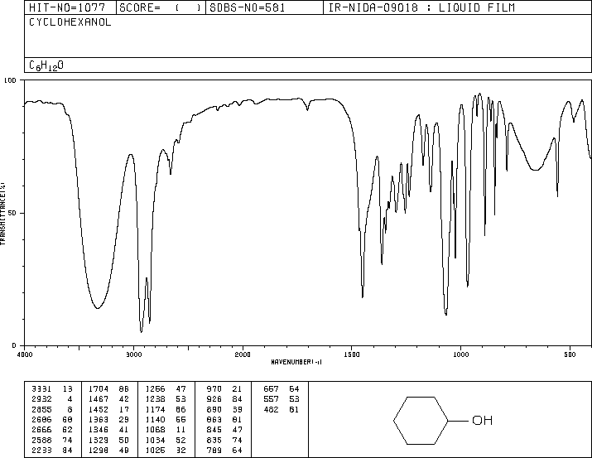

Example of an annotated IR spectrum:

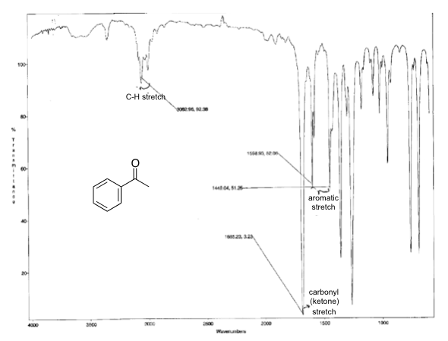
Characteristic Infrared Absorptions of Functional Groups
Group | Frequency (cm⁻¹) | Intensity
A. Alkyl
C-H stretch
A. Alkyl  C-H stretch | 2853 - 2962 | (m-s)
B. Alkenyl
=C-H stretch
C=C stretch
B. Alkenyl  =C-H stretch  C=C stretch | 3010 - 3095 | (m)
B. Alkenyl  =C-H stretch  C=C stretch | 1620 - 1680 | (v)
C. Alkynyl
≡C-H stretch
C≡C stretch
≡C-H bend
C. Alkynyl  ≡C-H stretch  C≡C stretch  ≡C-H bend | ~3300 | (s)
C. Alkynyl  ≡C-H stretch  C≡C stretch  ≡C-H bend | 2100-2260 | (v)
C. Alkynyl  ≡C-H stretch  C≡C stretch  ≡C-H bend | 600 -700 | (s)
D. Aromatic
Ar-H stretch
CC stretch
D. Aromatic  Ar-H stretch  CC stretch | ~3030 | (v)
D. Aromatic  Ar-H stretch  CC stretch | 1600-1585
E. Alcohols (OH stretch)
dilute solutions, OH stretch
hydrogen-bonded, OH stretch
C-O stretch
 | 3590-3650 | (sharp, v)
 | 3200-3550 | (broad, s)
 | 1050-1200 | (s)
F. Ethers
C-O stretch
F. Ethers  C-O stretch | 1070-1150 | (s)
G. Aldehydes
C=O stretch
C-H stretch
G. Aldehydes  C=O stretch  C-H stretch | 1690-1740 | (s)
G. Aldehydes  C=O stretch  C-H stretch | 2720 -2820 | (m)
H. Ketones
C=O stretch
H. Ketones  C=O stretch | 1680-1750 | (s)
I. Esters
C=O stretch
I. Esters  C=O stretch | 1735-1750 | (s)
J. Carboxylic acids
C=O stretch
Hydrogen-bonded OH stretch
J. Carboxylic acids  C=O stretch  Hydrogen-bonded OH stretch | 1710-1780 | (s)
J. Carboxylic acids  C=O stretch  Hydrogen-bonded OH stretch | 2500-3000 | (broad, v)
K. Amides
C=O stretch
N-H stretch
K. Amides  C=O stretch  N-H stretch | 1630-1690 | (s)
K. Amides  C=O stretch  N-H stretch | 3350-3500 | (s-m)
L. Amines
N-H stretch
L. Amines  N-H stretch | 3300-3500 | (m)
M. Nitriles
C≡N stretch
M. Nitriles  C≡N stretch | 2220-2260 | (m)
N. Nitro compounds
NO₂ stretch (asym)
NO₂ stretch (sym)
N. Nitro compounds  NO₂ stretch (asym)  NO₂ stretch (sym) | 1500-1660 | (s)
N. Nitro compounds  NO₂ stretch (asym)  NO₂ stretch (sym) | 1260-1390
s = strong, m = medium, w = weak, v = variable, ~ = approximately

Experiment 5 – Forensic Investigation
(Adapted from T. Sherlock by J. Powell and L. Powell)

As an expert in chemical toxicology, you are called to work on the following case:

A member of a famous English rock band was found in a coma in his dressing room after a gig. It was neither an attempted suicide nor a recreational drug overdose, but rather an intentional poisoning by a disgruntled fan unhappy with the musical direction the band was taking who put poison into the water bottle of the victim. The fan unfortunately committed suicide before the poison could be identified. However, a bottle of the poison was found near the comatose guitarist as well as the alleged contaminated water bottle.

This is where you come in. If the poison can be identified and quantified then an antidote can be administered. In the fan’s room was found samples of 3 poisons in liquid form. It is known that each of the poisons is undetectable in water by itself but since it must be pre-dissolved in one of the following organic solvents. If you can identify the solvent then the poison can be identified. The solvents are acetone, ethanol, and 1-propanol.

You have two samples. The first is a small sample of the actual poison, which is dissolved in one of the aforementioned solvents. You also have water bottle containing an undetermined amount of one of the solvent/poisons. If necessary, you have access to known samples of each of the 3 solvents.

First, identify which of the three solvents from the bottle of poison/solvent. Next, quantify the amount (% by volume) of that solvent in the water bottle. With that information, a suitable antidote can be formulated.

For equipment you have:

- Refractometer
- IR spectrophotometer
- Gas chromatograph

Please develop and propose a planned method on how to proceed. Have the plan approved before you begin any lab work.
Your proposal will be your pre-lab quiz.

Experiment 7 – Nucleophilic Substitution Reactions

Objectives:

1. Determine the percentage of each product in the reaction mixture by their refractive index, their densities, or gas chromatography.

2. Determine which reaction mechanism the reaction is going by, from the percentage of each product produced.

Introduction:

Nucleophilic substitution reactions among one of the many reactions you’ve studied involving alkyl halides. Other substrates (such as protonated alcohols) can also undergo nucleophilic substitution reactions. This experiment illustrates the type of laboratory work our understanding of these reactions is built on. The following is a brief, and by no means comprehensive, review of important topics that highlight the features of these reactions. In general, nucleophilic substitution (and elimination) reactions (which occasionally compete) depend on four factors (these factors are not absolute, exceptions do exist):
(1) substrate – primary, secondary, or tertiary carbon; special considerations include
delocalized charges in transition states such as with allyl/benzyl substituents
(2) leaving group – only the stable may depart; the stronger the conjugate acid of the
leaving group, the better the leaving group (TosO– > I– > Br– > Cl– >> HO–/H₂N–/F–)
however bad leaving groups can be converted to good leaving groups: (for example,
ROH + H₂SO₄  ROH₂⁺ or RNH₂ + H₂SO₄  RNH₃⁺ which is further susceptible to
nucleophilic attack (leading to substitution), β-carbon deprotonation (leading to
elimination), or leaving group dissociation (leading to carbocation formation, which is
subject to competing substitution or elimination))
(3) nucleophile – lone pairs are required! Nucleophilicity increases going down a
group (i.e. Br— is more nucleophilic than Cl–) and with increasing charge (i.e. HO– is
10,000 times more nucleophilic than H₂O). Nucleophilicity matters in S_{N}2 reactions
but not S_{N}1 as in unimolecular reactions the solvent is typically the nucleophile source
(4) solvent – both require polar solvents, but aprotic solvents (those without hydrogen
bonding between solvent molecules such as DMSO, HMPA, DMF, and acetone) favor
bimolecular (S_{N}2) pathways whereas protic solvents (such as water and alcohols,
which permit hydrogen bonding between solvent molecules) favor unimolecular
(S_{N}1) pathways. In S_{N}1 reactions, the more polar the solvent, the more stabilized the
carbocation intermediate; thus, the activation energy required to form it is lowered and
the reaction is faster.

To briefly review generic substitution and elimination mechanisms (E2 reactions omitted):
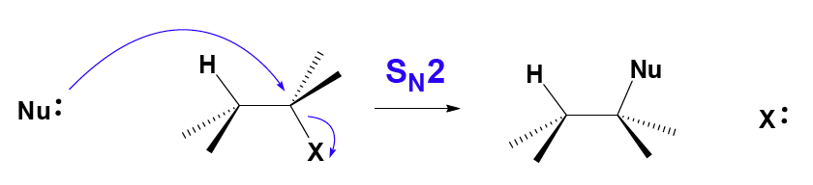
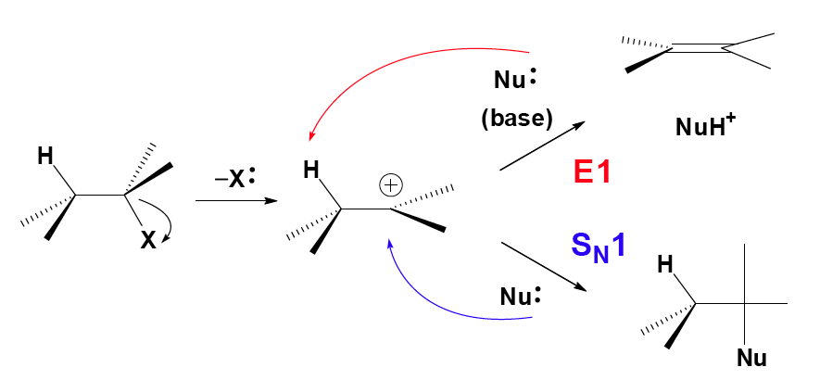
Recall that S_{N}2 reactions are “back-side attack” reactions and when they are occurring at a chiral center do so with inversion of configuration. On the other hand, S_{N}1 reactions proceed through free carbocations (as opposed to ion pairs) and tend to form racemic mixtures. An example of competing S_{N}1 and E1 reactions is seen below:
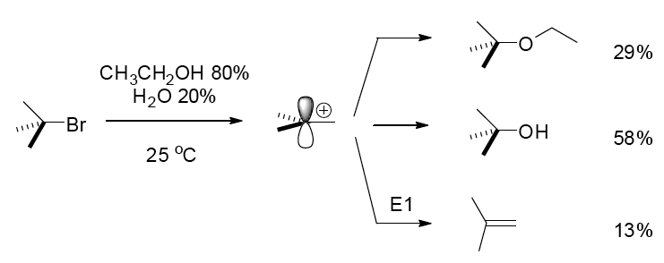
The competing reactions are due to sterics, which affect activation energy (kinetics) of the competing processes. Elimination reactions are favored by the presence of strong bases (such as HO–/RO– and H₂N–/RNH–/R₂N–). Two points in particular are studied in this experiment:

(1) Comparative nucleophilicitiy of the bromide and chloride ions
(2) Structure-activity relationships

Reactions:

Reactions 1 and 2: 1-butanol (butyl alcohol) substrate:

Reactions 3 and 4: 2-methyl-2-propanol (t-butyl alcohol) substrate:

When considering the mechanistic pathway for these reactions, here are some helpful hints:

- Poor leaving groups can be converted into good leaving groups via protonation
- In an acidic medium, the dominant form of the ammonia/ammounium equilibrium will favor the protonated form; NH₃ will be present but in very small amounts
- S_{N}2 reactions favor methyl and primary substrates
- S_{N}1 reactions favor tertiary substrates
- There are no carbocation rearrangements to be concerned with in these reactions
- Are there any competing elimination (E1 or E2) reactions to be concerned with? E2 reactions typically require the presence of strong base; E1 reactions compete with S_{N}1 reactions once the carbocation intermediate is formed
- Carbocation generation is made easier with increased temperature (think transition state/Arrhenius equation)
- Sulfuric acid is a catalyst – catalysts are used and regenerated over the course of a reaction.
- The solvent for this reaction is water (initially ice); alcohols are miscible in water. How does the solvent affect the reaction pathway?

Procedure:

Preparation of the solvent-nucleophile medium:

Place 50 grams of ice in a 250 mL Erlenmeyer flask and carefully add 38 ml of concentrated sulfuric acid. Set this mixture aside to cool. Weigh out 0.18 moles of ammonium chloride and
0.18 moles of ammonium bromide (i. e. both ammonium salts) into a 250 mL beaker. Crush any lumps of these reagents to a powder and transfer these solids to a 500 mL Erlenmeyer flask using a powder funnel. Cautiously add the sulfuric acid solution to the ammonium salts a little at a time. Swirl the flask to induce the salts to dissolve. Heat the mixture on a steam bath to achieve total solution. When dissolution has been completely achieved, allow the liquid to cool for no more than one minute. Once cool, pour 35 mL of the sulfuric acid-ammonium salt mixture into a 125 mL separatory funnel (for the t-butyl alcohol reaction) and the remainder into a 500 mL round bottom flask for reflux (for the n-butyl alcohol reaction). A small portion of the salts in the separatory funnel or the round bottom flask or both may precipitate out as the solution cools. Do not worry about these yet; they will re-dissolve during the reactions.

Reactions with 1-butanol:

Connect the 500 mL round bottom flask with the sulfuric acid/ammonium salts mixture to a condenser and add a white boiling chip to the flask. Add 5 mL of 1-butanol through the condenser drop wise. Start the water circulating in the condenser and then reflux gently for 75 minutes with a heating mantle. After reflux, cool the reaction flask in an ice water bath before disassembling the reflux apparatus. Transfer the cooled mixture by decanting is to a 125 mL separatory funnel, taking care to leave behind any solid precipitate. Allow the layers to separate and drain the aqueous layer. Add 10 mL of water to the organic layers, shake, and separate. Wash the organic layer with 10 mL of sodium hydrogen carbonate solution, separate, and drain the organic layer into a 50 mL beaker containing about 500 mg of anhydrous sodium sulfate. When the solution is clear, decant the product solution into a 50 mL Erlenmeyer flask containing a few beads of anhydrous calcium chloride. Stopper the flask, label it, and submit it for gas chromatography analysis.

Reactions with 2-methyl-2-propanol (common name: t-butyl alcohol/t-butanol): If this reaction is not done during the same lab period, transfer the 35 mL of solvent/nucleophile medium to a 125 mL Erlenmeyer flask, cork, and store. Measure 5 mL of 2-methyl-2-propanol in a warm graduated cylinder and add this to the separatory funnel containing 35 mL of the warm sulfuric acid/ammonium salts solution. Vent the funnel several times and repeat this until pressures are substantially equalized. After equalizing, invert the funnel and shake vigorously with occasional venting for 2 minutes. After shaking, allow the layers to separate for no more than 1 minute. Drain off most of the aqueous layer, wait 30 seconds, then drain off the rest of the aqueous layer formed and a little of the organic layer into a beaker to be certain that there is no water in the organic layer. Drain the remainder of the organic layer into a 50 mL beaker containing about 1 g of solid sodium hydrogen carbonate. Once the bubbling stops and a clear liquid is obtained, decant the liquid into a clean, dry 50 mL Erlenmeyer flask containing a few beads of anhydrous calcium chloride. Stopper the Erlenmeyer flask, label it, and submit it for gas chromatography analysis.

Gas chromatography analysis:

The retention times of similar compounds are usually in the order of increasing boiling points. The sensitivity of a thermal conductivity detector, such as that used in the instrument employed for this experiment, is nearly the same for comparable compounds.
Pre-lab writeup:

Include the equations (including proposed mechanisms) for the overall reactions, the table of physical constants and quantities of substances used, and a flow chart for isolation of the products (substitution and elimination). As always, the pre write-up is to be checked by the instructor or assistant before the experiment is begun. It is not necessary to determine the limiting reagent or theoretical yield.

Two reaction mixtures: | Reaction 1  Reaction 2 |  | Reaction 3  Reaction 4
Substrate | 1-butanol | 1-butanol | t-butyl alcohol | t-butyl alcohol
Catalyst | H₂SO₄ | H₂SO₄ | H₂SO₄ | H₂SO₄
Ammonium salt | NH₄Cl | NH₄Br | NH₄Cl | NH₄Br
Nucleophile | Cl– | Br– | Cl– | Br–
Product | 1-chlorobutane | 1-bromobutane | t-butyl chloride | t-butyl bromide
Mechanism
(S_{N}1 or S_{N}2)
% yield by GC

Results/Analysis:

Comment specifically on the following:
- Product percent yields for each reaction. The relative quantities of the halides in each reaction, based on the percent of each produced as calculated from the peak areas.
- The relative rates of nucleophilic attack on each reactant at these temperatures based on the ratio calculated from the peak areas.
- The relative reactivity of the alcohols based on the reaction conditions.

Notes:

  - This medium will be used for both the n-butyl alcohol and the t-butyl alcohol. Ammonium salts are used because both are soluble at the concentration needed for this conversion.
  - If the solution is cooled too much, the ammonium salts may start to crystallize out. Allow the mixture to stand on the heat bath until your reflux apparatus is set up and then allow to cool. It may be necessary to reheat the mixture if crystallization occurs. Violent boiling will cause loss of product. A small amount of hydrogen chloride gas may be emitted from the condenser; this does not indicate a loss of product.
  - Be careful not to shake the hot solution as you remove the heating mantle or a violent boiling and bubbling action will result, causing loss of material out of the top of the condenser. Any solids that were originally present in the separatory funnel should dissolve during this period.
  - Enough anhydrous calcium chloride should be added so that the beads are free flowing.
  - There will be a lot of pressure build up from the mixing of the warm liquids. Frequent venting is necessary to prevent blow out of the reaction mixture.
  - In this experiment any halogen exchange (i.e. alkyl halide substitution to form a different alkyl halide) is negligible because the products are insoluble in the reaction mixture and are not in the same phase as the ions.
References:

Introduction to Organic Laboratory Techniques, 3rd Ed., Pavia, Lampman and Kriz

Experiment 24, pp. 178-183 Gas Chromatography: Quantitative Analysis, pp. 629-640

Sample data:

1-butanol reaction:

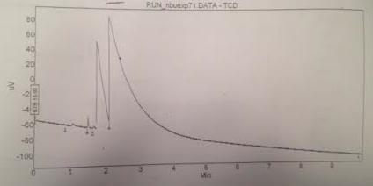
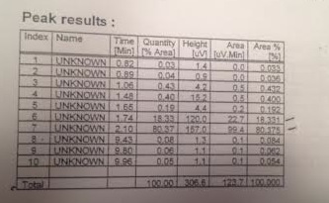

t-butanol reaction:

