Rowan College at Burlington County
CHE 241
Experiment 7 – Nucleophilic Substitution Reactions

Objectives:

1. Determine the percentage of each product in the reaction mixture by their refractive index, their densities, and gas chromatography.

2. Determine which reaction mechanism the reaction is going by, from the percentage of each product produced.

Introduction:

Nucleophilic substitution reactions among one of the many reactions you’ve studied involving alkyl halides. Other substrates (such as protonated alcohols) can also undergo nucleophilic substitution reactions. This experiment illustrates the type of laboratory work our understanding of these reactions is built on. The following is a brief, and by no means comprehensive, review of important topics that highlight the features of these reactions. In general, nucleophilic substitution (and elimination) reactions (which occasionally compete) depend on four factors (these factors are not absolute, exceptions do exist):
(1) substrate – primary, secondary, or tertiary carbon; special considerations include
delocalized charges in transition states such as with allyl/benzyl substituents
(2) leaving group – only the stable may depart; the stronger the conjugate acid of the
leaving group, the better the leaving group (TosO– > I– > Br– > Cl– >> HO–/H₂N–/F–)
however bad leaving groups can be converted to good leaving groups: (for example,
ROH + H₂SO₄  ROH₂⁺ or RNH₂ + H₂SO₄  RNH₃⁺ which is further susceptible to
nucleophilic attack (leading to substitution), β-carbon deprotonation (leading to
elimination), or leaving group dissociation (leading to carbocation formation, which is
subject to competing substitution or elimination))
(3) nucleophile – lone pairs are required! Nucleophilicity increases going down a
group (i.e. Br— is more nucleophilic than Cl–) and with increasing charge (i.e. HO– is
10,000 times more nucleophilic than H₂O). Nucleophilicity matters in S_{N}2 reactions
but not S_{N}1 as in unimolecular reactions the solvent is typically the nucleophile source
(4) solvent – both require polar solvents, but aprotic solvents (those without hydrogen
bonding between solvent molecules such as DMSO, HMPA, DMF, and acetone) favor
bimolecular (S_{N}2) pathways whereas protic solvents (such as water and alcohols,
which permit hydrogen bonding between solvent molecules) favor unimolecular
(S_{N}1) pathways. In S_{N}1 reactions, the more polar the solvent, the more stabilized the
carbocation intermediate; thus, the activation energy required to form it is lowered and
the reaction is faster.

To briefly review generic substitution and elimination mechanisms (E2 reactions omitted):
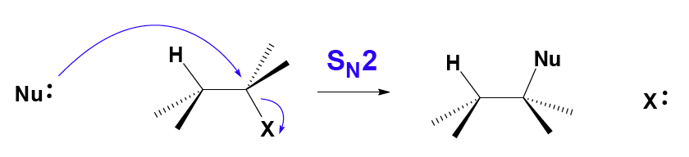
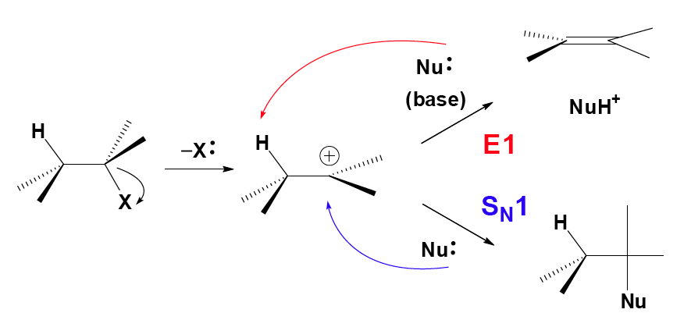
Recall that S_{N}2 reactions are “back-side attack” reactions and when they are occurring at a chiral center do so with inversion of configuration. On the other hand, S_{N}1 reactions proceed through free carbocations (as opposed to ion pairs) and tend to form racemic mixtures. An example of competing S_{N}1 and E1 reactions is seen below:
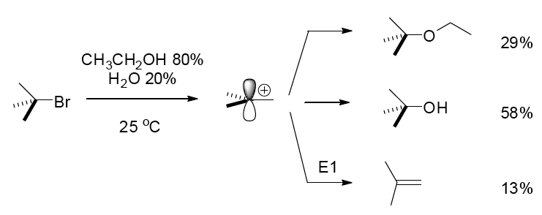
The competing reactions are due to sterics, which affect activation energy (kinetics) of the competing processes. Elimination reactions are favored by the presence of strong bases (such as HO–/RO– and H₂N–/RNH–/R₂N–). Two points in particular are studied in this experiment:

(1) Comparative nucleophilicity of the bromide and chloride ions
(2) Structure-activity relationships

Reactions:

Reactions 1 and 2: 1-butanol (butyl alcohol) substrate:

Reactions 3 and 4: 2-methyl-2-propanol (t-butyl alcohol) substrate:

When considering the mechanistic pathway for these reactions, here are some helpful hints:

- Poor leaving groups can be converted into good leaving groups via protonation
- In an acidic medium, the dominant form of the ammonia/ammonium equilibrium will favor the protonated form; NH₃ will be present but in very small amounts
- S_{N}2 reactions favor methyl and primary substrates
- S_{N}1 reactions favor tertiary substrates
- There are no carbocation rearrangements to be concerned with in these reactions
- Are there any competing elimination (E1 or E2) reactions to be concerned with? E2 reactions typically require the presence of strong base; E1 reactions compete with S_{N}1 reactions once the carbocation intermediate is formed
- Carbocation generation is made easier with increased temperature (think transition state/Arrhenius equation)
- Sulfuric acid is a catalyst – catalysts are used and regenerated over the course of a reaction.
- The solvent for this reaction is water (initially ice); alcohols are miscible in water. How does the solvent affect the reaction pathway?

Procedure:

Preparation of the solvent-nucleophile medium:

Place 50 grams of ice in a 250 mL Erlenmeyer flask and carefully add 38 ml of concentrated sulfuric acid. Set this mixture aside to cool. Weigh out 0.18 moles of ammonium chloride and
0.18 moles of ammonium bromide (i. e. both ammonium salts) into a 250 mL beaker. Crush any lumps of these reagents to a powder and transfer these solids to a 500 mL Erlenmeyer flask using a powder funnel. Cautiously add the sulfuric acid solution to the ammonium salts a little at a time. Swirl the flask to induce the salts to dissolve. Heat the mixture on a steam bath to achieve total solution¹. When dissolution has been completely achieved, allow the liquid to cool for no more than one minute². Once cool, pour 35 mL of the sulfuric acid-ammonium salt mixture into a 125 mL separatory funnel (for the t-butyl alcohol reaction) and the remainder into a 500 mL round bottom flask for reflux (for the n-butyl alcohol reaction). A small portion of the salts in the separatory funnel or the round bottom flask or both may precipitate out as the solution cools. Do not worry about these yet; they will re-dissolve during the reactions.

Reactions with 1-butanol:

Connect the 500 mL round bottom flask with the sulfuric acid/ammonium salts mixture to a condenser and add a white boiling chip to the flask. Add 5 mL of 1-butanol through the condenser drop wise. Start the water circulating in the condenser and then reflux gently for 75 minutes with a heating mantle. After reflux, cool the reaction flask in an ice water bath before disassembling the reflux apparatus³. Store the mixture in a well-sealed jar. [End week 1 here.]
Allow the layers to separate and drain the aqueous layer. Add 10 mL of water to the organic layers, shake, and separate. Wash the organic layer with 10 mL of sodium hydrogen carbonate solution, separate, and drain the organic layer into a 50 mL beaker containing about 500 mg of anhydrous sodium sulfate. When the solution is clear, decant the product solution into a 50 mL Erlenmeyer flask containing a few beads of anhydrous calcium chloride⁴. Stopper the flask, label it, and submit it for gas chromatography analysis.

Reactions with 2-methyl-2-propanol (common name: t-butyl alcohol/t-butanol): If this reaction is not done during the same lab period, transfer the 35 mL of solvent/nucleophile medium to a 125 mL Erlenmeyer flask, cork, and store. Measure 5 mL of 2-methyl-2-propanol in a warm graduated cylinder and add this to the separatory funnel containing 35 mL of the warm sulfuric acid/ammonium salts solution. Vent the funnel several times and repeat this until pressures are substantially equalized⁵. After equalizing, invert the funnel and shake vigorously with occasional venting for 2 minutes. After shaking, allow the layers to separate for no more than 1 minute. Drain off most of the aqueous layer, wait 30 seconds, then drain off the rest of the aqueous layer formed and a little of the organic layer into a beaker to be certain that there is no water in the organic layer. Drain the remainder of the organic layer into a 50 mL beaker containing about 1 g of solid sodium hydrogen carbonate. Once the bubbling stops and a clear liquid is obtained, decant the liquid into a clean, dry 50 mL Erlenmeyer flask containing a few beads of anhydrous calcium chloride⁴. Stopper the Erlenmeyer flask, label it, and submit it for gas chromatography analysis.

Gas chromatography analysis:

The retention times of similar compounds are usually in the order of increasing boiling points. The sensitivity of a thermal conductivity detector, such as that used in the instrument employed for this experiment, is nearly the same for comparable compounds⁶.

Pre-lab writeup:

Include the equations (including proposed mechanisms) for the overall reactions, the table of physical constants and quantities of substances used, and a flow chart for isolation of the products (substitution and elimination). As always, the pre-write-up is to be checked by the instructor or assistant before the experiment is begun. It is not necessary to determine the limiting reagent or theoretical yield.

Two reaction mixtures: | Reaction 1  Reaction 2 |  | Reaction 3  Reaction 4
Substrate | 1-butanol | 1-butanol | t-butyl alcohol | t-butyl alcohol
Catalyst | H₂SO₄ | H₂SO₄ | H₂SO₄ | H₂SO₄
Ammonium salt | NH₄Cl | NH₄Br | NH₄Cl | NH₄Br
Nucleophile | Cl– | Br– | Cl– | Br–
Product | 1-chlorobutane | 1-bromobutane | t-butyl chloride | t-butyl bromide
Mechanism
(S_{N}1 or S_{N}2)
% yield by GC

Results/Analysis:

Comment specifically on the following:
- Product percent yields for each reaction. The relative quantities of the halides in each reaction, based on the percent of each produced as calculated from the peak areas.
- The relative rates of nucleophilic attack on each reactant at these temperatures based on the ratio calculated from the peak areas.
- The relative reactivity of the alcohols based on the reaction conditions.

Notes:

  - This medium will be used for both the n-butyl alcohol and the t-butyl alcohol. Ammonium salts are used because both are soluble at the concentration needed for this conversion.
  - If the solution is cooled too much, the ammonium salts may start to crystallize out. Allow the mixture to stand on the heat bath until your reflux apparatus is set up and then allow to cool. It may be necessary to reheat the mixture if crystallization occurs. Violent boiling will cause loss of product. A small amount of hydrogen chloride gas may be emitted from the condenser; this does not indicate a loss of product.
  - Be careful not to shake the hot solution as you remove the heating mantle or a violent boiling and bubbling action will result, causing loss of material out of the top of the condenser. Any solids that were originally present in the separatory funnel should dissolve during this period.
  - Enough anhydrous calcium chloride should be added so that the beads are free flowing.
  - There will be a lot of pressure build up from the mixing of the warm liquids. Frequent venting is necessary to prevent blow out of the reaction mixture.
  - In this experiment any halogen exchange (i.e. alkyl halide substitution to form a different alkyl halide) is negligible because the products are insoluble in the reaction mixture and are not in the same phase as the ions.
