EXPERIMENT X

Friedel-Crafts Reaction - 1,4-Di-t-butyl-2,5-dimethoxybenzene

REFERENCES: Organic Experiments, 7th Ed., Fieser and Williamson, p. 359

OBJECTIVES: The student should be able to:

1. Remove an acid from the reaction mixture.
2. Recrystallize a solid product.
3. Calculate the mole and gram amounts of reactants given the grams
of product.
4. Identify the product from its melting point, and IR spectra.

INTRODUCTION: This preparation is an example of a Friedel-Crafts reaction occurring on an activated benzene molecule, hydroquinone dimethyl ether. The usual Friedel-Crafts reagents, aluminum chloride and an alkyl chloride are not used to produce the alkyl carbonium ion, the electrophilic reagent in this reaction. Instead a tertiary alcohol and sulfuric acid will be used to produce the electrophilic reagent.

REACTION EQUATIONS:
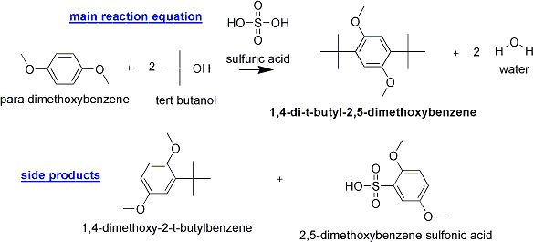

REAGENTS:

Reactants: Hydroquinone dimethyl ether (1,4-dimethoxybenzene);
t-butyl alcohol

Solvent: Acetic acid, 20 ml

Catalysts: Conc. Sulfuric acid, 20 ml

Calculate the amounts of the reactants required to yield 10.0 grams of 1,4-di-t-butyl-2,5-dimethoxybenzene assuming a 100% yield.

Use this theoretical amount of 1,4-dimethoxybenzene.

Use a 30% excess of t-butyl alcohol.

When calculating amounts of reactants, round mole values to 4 decimal places, final masses to 1 decimal place and final volumes to whole numbers.

APPARATUS:

125 ml Erlenmeyer flask; 50 ml Erlenmeyer flask; 125 ml dropping funnel

DIRECTIONS:

Hydroquinone dimethyl ether1, t-butyl alcohol and acetic acid are placed in a 125 ml erlenmeyer flask and dissolved on a steam bath. The flask is then cooled in an ice bath until the temperature is 0-3 oC. The concentrated sulfuric acid is placed in a 50 ml erlenmeyer flask and the flask is placed in the ice bath. A 125 ml dropping funnel is positioned over the 125 ml erlenmeyer flask containing the hydroquinone dimethyl ether solution in the ice bath and the chilled sulfuric acid solution is poured into the dropping funnel. The chilled sulfuric acid is added in slow drops over a period of 15-20 minutes to the hydroquinone dimethyl ether solution. The flask containing the hydroquinone dimethyl ether solution is swirled constantly while remaining in the ice bath. The solid reaction product should have separated at this time and the temperature of the reaction mixture should have risen to 20-25 OC. Swirl the mixture at 25 OC for about 5 more minutes and then cool in ice.

Add enough ice to decompose the excess sulfuric acid and then fill the flask with water, cool, and filter the crystals by suction using two filter papers. Apply only very gentle suction to avoid breaking the filter paper while filtering the acid solution. Wash with water and then turn on the suction full force. Press down the crystals and allow them to drain well. Turn off the suction and add 10 ml of a cooled solution of methanol to the crystals and apply suction. Repeat this procedure two more times.

The crystals are dried and recrystallized from methanol. The melting point of the product is determined, and an IR spectrum is run. The product should be turned in, and all physical constants reported.

NOTES:

1. Grind the hydroquinone dimethyl ether in a mortar and pestle before weighing.

CJF
Revised 01/24

